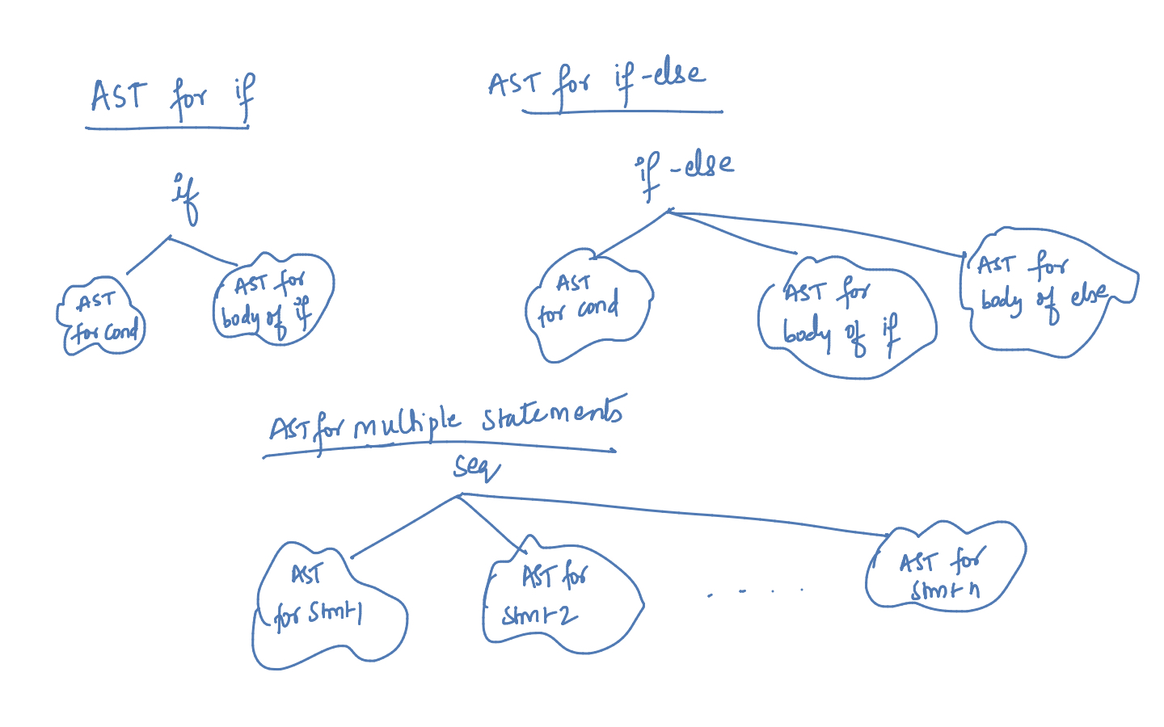

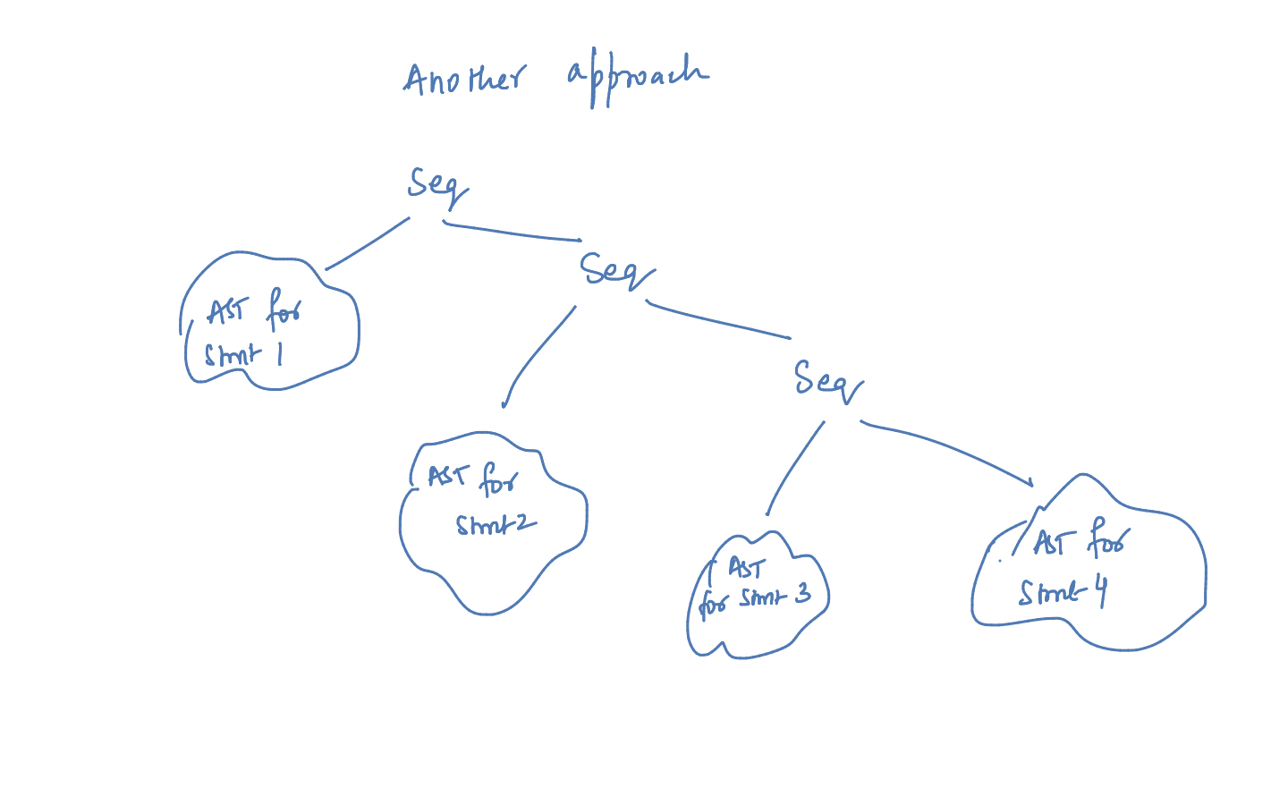

**Input 1 :**

if(a > b)

{

a = a + 1;

b = b - 1;

}

AST :

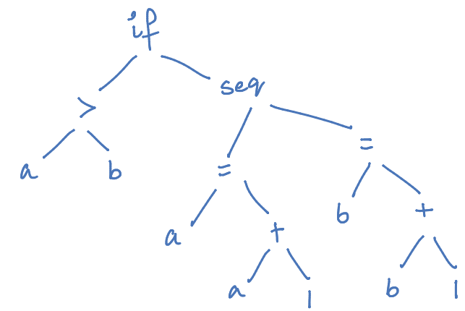

**Output 1 : (Print any one way)**

Preorder Traversal of AST :

if, >, a, b, seq, =, a, +, a, 1, =, b, +, b, 1

Postorder traversal,

a, b, a, a, 1, +, =, b, b, 1, +, =, seq, if

**Input 2 :**

if(a > b)

{

a = a + 1;

b = b - 1;

}

else

{

a = a - 1;

b = b -1;

}

AST:

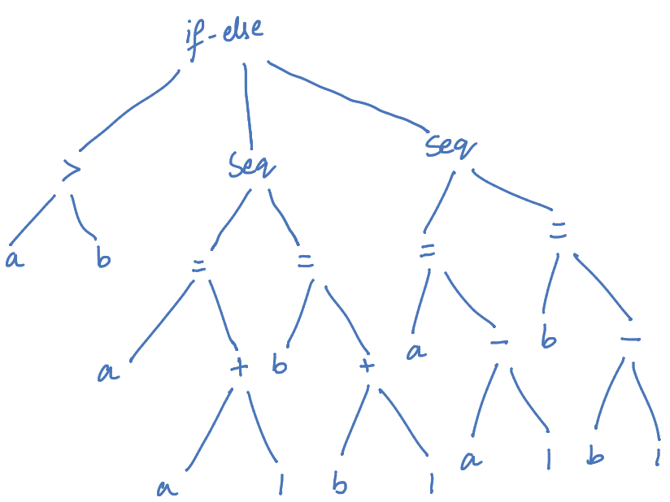

**Output 2 : (Print any one way)**

Preorder Traversal of AST :

if-else, >, a, b, seq, =, a, +, a, 1, =, b, +, b, 1, seq, =, a, -, a, 1, =, b, -, b, 1

Postorder Traversal of AST :

a, b, >, a, a, 1, +, =, b, b, 1, +, =, seq, a, a, 1, -, =, b, b, 1, -, =, seq, if-else

**Input 3 :**

if(a > b)

{

a = a + 1;

b = b - 1;

}

else

{

a = a - 1;

b = b -1;

if (b < 0)

{

b= b + 1;

}

else

{

b = 0;

}

}

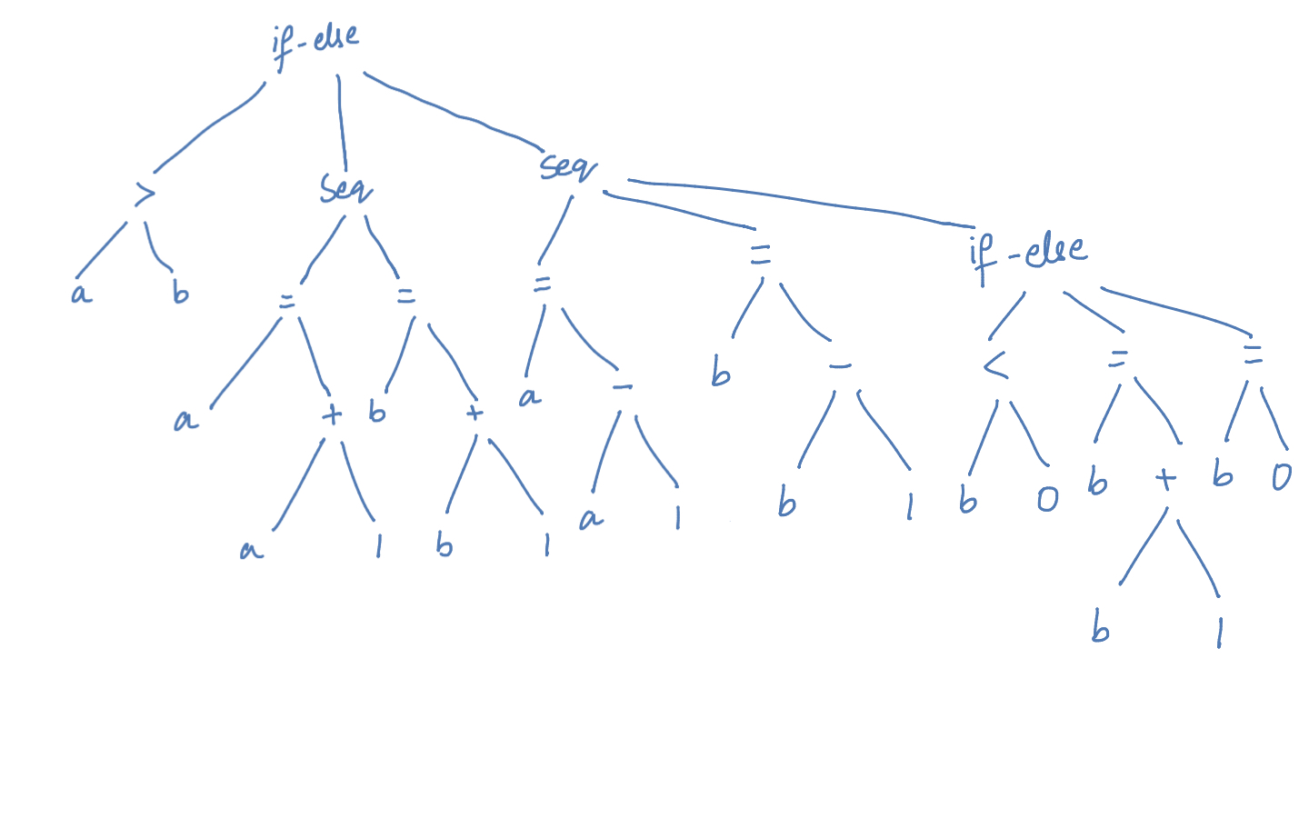

**Output 3 : (Print any one way)**

Preorder Traversal of AST:

if-else, >, a, b, seq, =, a, +, a, 1, =, b, +, b, 1, seq, =, a, -, a, 1, =, b, -, b, 1, if-else, <, b, 0, =, b, +, b, 1, =, b, 0

Postorder Traversal of AST:

a, b, >, a, a, 1, +, =, b, b, 1, +, =, seq, a, a, 1, -, b, b, 1, -, =, b, 0, <, b, b, 1, +, =, b, 0, =, if-else, seq, if-else